**Create and configure the Telegram Bot**

Step 1. Open Telegram, Enter @Botfather in the search tab and choose this bot.

Step 2. Click “Start” to activate BotFather bot. In response, you receive a list of commands to manage bots.

Step 3. Choose or type the /newbot command and send it.

Step 4. Choose a name for your bot — your subscribers will see it in the conversation.

Step 5. Choose a username for your bot — the bot can be found by its username in searches. The username must be unique and end with the word “bot.”

Step 6. The bot is created. Copy the Token to access HTTP API

Step 7. Type /setprivacy command and choose your Bot username

Step 8. You have to Disable the privacy to allow bot to receive all messages that people send to groups.

**Webhook and Fetching Messages**

Install ngrok

Ngrok

Ngrok http 6900

login

[Himanshurelhan80@gmail.com](mailto:Himanshurelhan80@gmail.com)

Bigin@123

Step 1. Create a Webhook URL for event-driven communication between 2 application programming interfaces(APIs)

Webhook_URL = Server_URL + “/webhook” + Telegram_Bot_Token

Step 2. Set Webhook

Telegram_API + “/setwebhook?url=” + Webhook_URL

Step 3. Extract required values from the request that you want to push in ZOHO Bigin using optional chaining method

const **group_name** = req?.body?.message?.chat?.title;

const **user_name** = req?.body?.message?.from?.username;

const **first_name** = req?.body?.message?.from?.first_name;

const **last_name** = req?.body?.message?.from?.last_name;

const **unixDate** = req?.body?.message?.date;

const **message** = req?.body?.message?.text;

Step 4. Decode the **unixDate** and modify it as the required time and date format.

Step 5. Create a Final message that you want to push on Zoho Bigin

const **content** =`${group_name} | ${user_name} | ${finalDate} ${finalTime} - ${message}`;

**Telegram and Bigin Integration**

Step 1. Now it’s time to Push Fetched message into ZOHO Bigin. First Generate access Token for ZOHO BIGIN using Zoho developer console and APIs.

Step 2. Login to ZOHO Bigin using your credentials and navigate to a specific record.

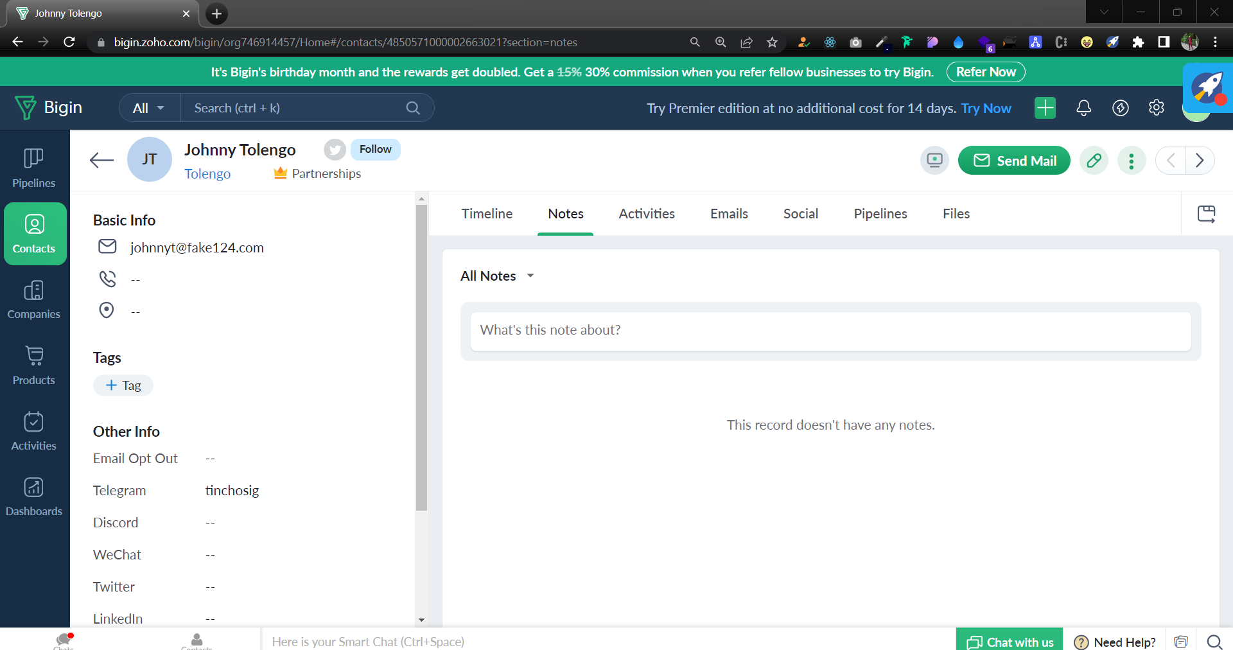

Copy its id from the URL. In this case it’s - 4850571000002663021

Step 3. Simply create a HTTP POST method request which has access token and data to be sent using ZOHO Bigin API with the contact id which you have copied

https://www.zohoapis.com/bigin/v1/Deals/${contact_id}/Notes?